

St. Luke Lutheran Church

32764 Northside Parkway, NW  
Atlanta, GA 30327

[www.stlukeatlanta.org](http://www.stlukeatlanta.org)

Kim Donina 404-697-1991

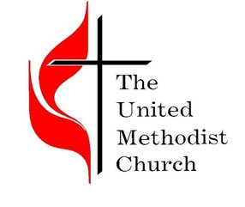

760 Hurt Road

Smyrna, GA

770-436-2675

[office@bethanyumc.net](mailto:office@bethanyumc.net)

Rhythmz & Motion

Dance Studio

3791 S. Cobb Dr.

Smyrna, GA 30080

Niya Thomas

678- 309-5911

[rhythmzandmotion@gmail.com](mailto:rhythmzandmotion@gmail.com)

4480 S. Cobb Dr.

Smyrna, GA 30082

Max Angel

404-918-4810

1000 EMC Parkway

Marietta, GA 30060

[Kelly.bodner@cobbemc.com](mailto:Kelly.bodner@cobbemc.com)

2950 Canton Rd. #250

Marietta, GA 30066

Jaime Collins

(770) 321-4078

[jaime@thesteamclub.com](mailto:jaime@thesteamclub.com)

3951 Austell Road Austell, GA 30001

Penny Wilkerson

770-732-8838

Bethany

Pugmire-Lincoln Mercury 1865 Cobb Parkway

Marietta, GA 30062 770-952-2261

The Presbyterian Village 2000 East West Connector Austell, GA 30106

770-819-7417